eCMS MANUAL

Authorised Compliance Trader(ACT)

Department of Revenue and Customs
Ministry of Finance
Table of Contents
1
1. Introduction 1
2. Login as Act Officer 1
3. Approval 2

Introduction
An external user can apply for Authorized Compliant Trader (ACT) in eCMS. ACT are accorded certain procedural advantages in eCMS which result in a quicker and smoother clearance.

Login as Act Officer
- The user needs to log into eCMS using the url: www.ecms.gov.bt

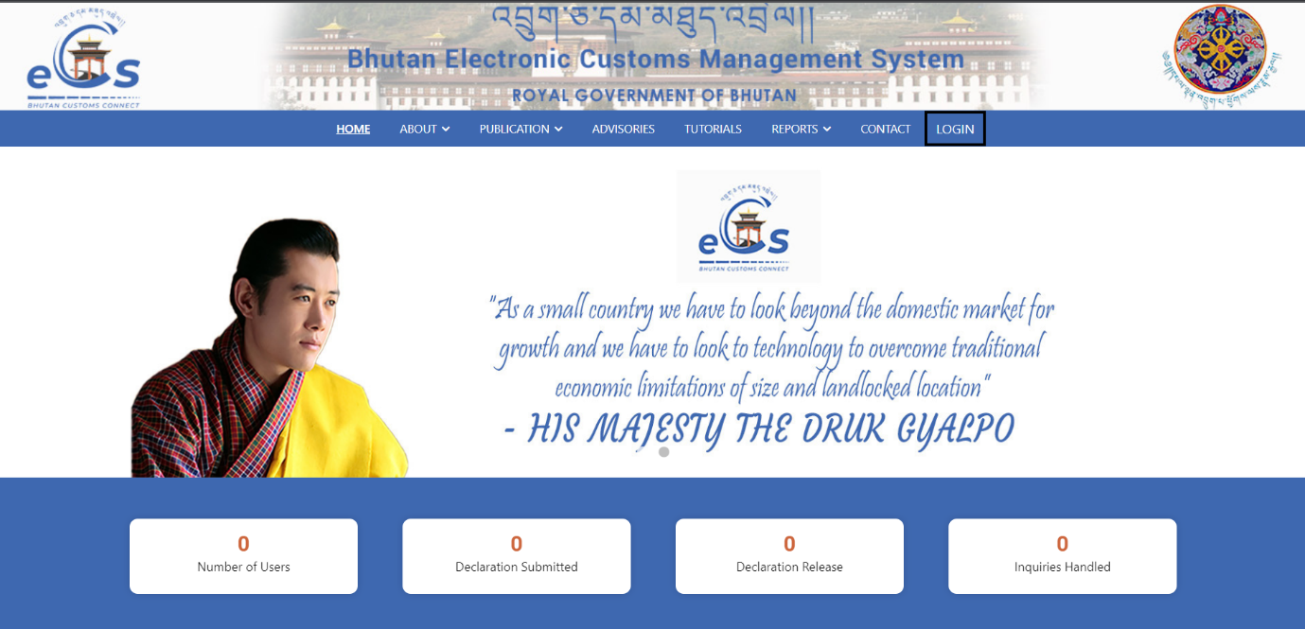

- Click on login menu and provide the required credentials to log in to the system:

Approval
- Go to ACT Registration and click on Verifier.
- Click on ACT registration number to verify the application.
- Go to Inspection checklist, tick on comply option and update.
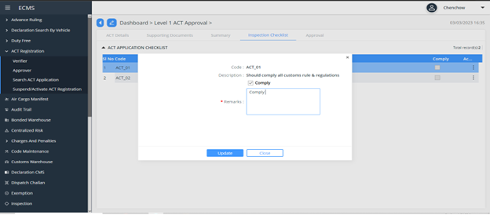

- Click Approval button and change the status as ‘Approved’.
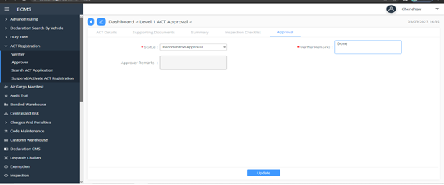

- ACT registration number will appear.
